PROJECT-NAME: PharmEasy

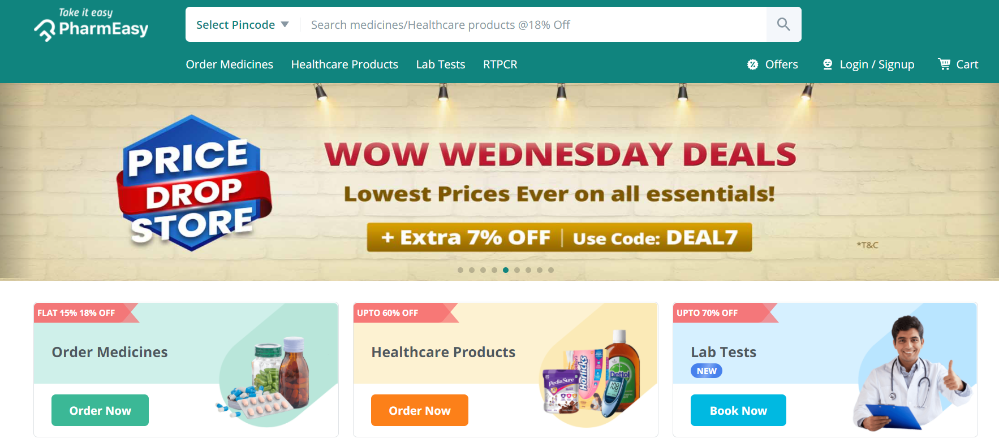

OVERVIEW: It’s an e-commerce website for Medical store. Here, customers will find the Medicines according the the prescriptions, even can consult with doctors and can book there lab test appointments.
Not only that, customers can find the regularly used Healthcare products at the right price with no extra charges for delivery with the basic checks.

HOME PAGE:
- LOGO
- Social Media Icons
- Search Bar
- Buttons/icons (Login/ Signup/ Cart)
- Menu Bar (Text/Links)
- Main Banner - (IMAGE)
- Product Categories - ( clickable product cards, view more button)
- Discount Banners - (clickable Images)
Footer – ( Copyright logo and designer name with some information)

MAIN PAGE:

- Filters ( Categories, Brands, Prices ,Quick Deals)
- Product Cards (clickable Images, product name, prices)
- Various Subscriptions

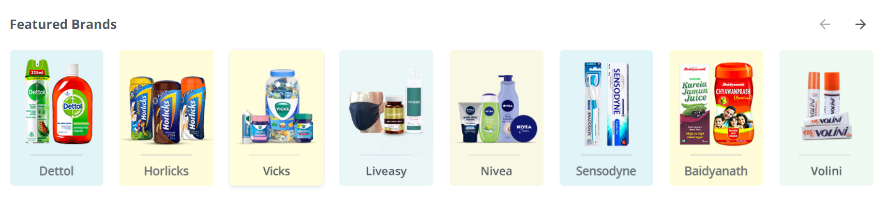

DETAILS PAGE:
- Product Name
- Product price
- About Product
- About Manufacturer
- Reviews
- Add to cart and Buy now Buttons
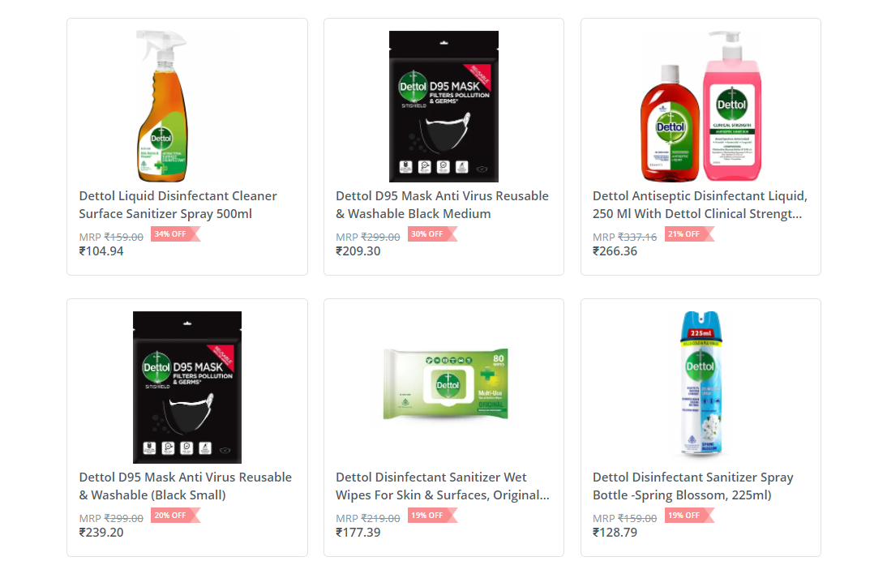

REGISTRATION FORM:
- E-mail address
- User Name
- Password
- Confirm Password

Login Form:
- E-mail address
- Password

PAYMENT PAGE:
- Order Summary
- Address Selection
- Payment method - (card, wallet, UPI, Net Banking, etc)

